

***Restaurant BILLING Management SYSTEM***

**BY**

SADIA SUBRUN PROMA

( ID: 181-35-2295)

***TO***

*Rashed Karim*

*Deputy Director,IT*

*Daffodil International University*

A course project (SE 231: System analysis and design project) submitted in

Fulfillment of the requirement for the degree of Bachelor of Science in

Software Engineering

***Department of Software Engineering***

***DAFFODIL INTERNATIONAL UNIVERSITY***

Fall-2019

**Copyright © 2019 by Daffodil International University**

“Restaurant Billing Management System”

This project “Restaurant billing management system”, is a java project which run on netbeans.We can also run this project in eclipse.With this software the process of a restaurant food selling system can be completed.This project is so simple that no registration or Log-In system has been giver here.So the software is very easy to use and anybody can use this software easily.The first page of the software will have the Manu of the restaurant and customer information enter option.There is also an alert message for incorrect food code.

So,manager will benefit greatly from using this software,as this software will help to automatically bill the food orders of the restaurant.

**Contents of the SRS**

1. **Category:** What kind of software is it?
   1. Desktop application/Web application/ Android app.
2. **Purpose:** Describe what is the purpose of making this system.
3. **Scope:** What is the area it covering, what is its range, to what limits it will help you.
4. **Introduction:**  Define the Proposed system.
5. **Use case diagram:** The use case diagram of this project.
6. **Advantages:**  Define the advantages of the system. *(In every perspective).*
7. **Functional Requirements of the System:** The requirements that specify the functional aspects of software are known as functional requirements.
8. **Non-Functional Requirements of the System :** The requirements that are not related to the functional aspect of software fall into the non-functional requirements category.
9. **Software Tools:** Mention the software tools which will involve in all this development process.
10. **Deployment:**  What kind of Environment will be needed to deploy the Software?
    1. OS, RAM, Processor and etc.
11. **Hardware Specifications:**  The hardware required to develop this system.

**“Restaurant billing Management System”**

**Category**

It is a Desktop application

**SCOPE**

With this software the process of selling a restaurant food can be completed

**INTRODUCTION**

**Proposed System**

The system after careful analysis has been identified to be presented with the following modules:

* **Customer identity:** Manager has to enter customer name and id.
* **Food selection:** Manager has to enter the correct food code.
* **Quantity:** Manager has to enter quantity of food.
* **Calculation:** The system can calculate individual price of food and also can calculate total bill of a customer.
* **Signature:** There is an automatic signature display of hope manager.
* **Refresh :** There is also a refresh option .

**Advantages**

* Time and Cost Saving
* Reduces the hassle of accounting separately in an account
* This software will facilitate the work of a restaurant manager
* The software will have provide discount option for old customers in future
* This software will bring flexibility to the manager of the restaurant

**FUNCTIONAL REQUIREMENTS**

"Functional requirement describe what a system should do."Functional requirements of our system are explained below.

* Only restaurent manager can access the system.
* Shop manager can choice new or old customers.
* Manager can enter customer name and id.
* Manager can enter selected food code.
* Manager can enter quantity of selected food list.
* The system can calculate individual price of food and also can calculate total bill of a customer.
* There is also a refresh option .

**NON FUNCTIONAL REQUIREMENTS**

Requirement that specifies criteria that can be used to judge the operation of a system are called non-functional requirements. Non-functional requirements of our system are mentioned below

* + - Manager details.
    - Better component design.
    - There is an automatic signature display of manager.

**SOFTWARE TOOLS**

**Database Server:** Microsoft SQL Server-2014

**Development Tools:** NetBeans

**Programming Language:** java

Use Case Diagram

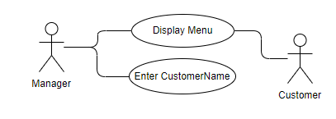

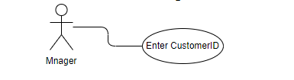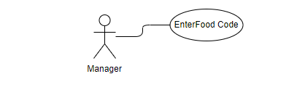

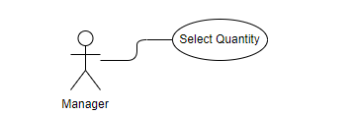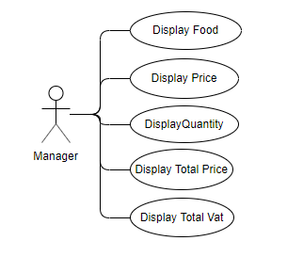

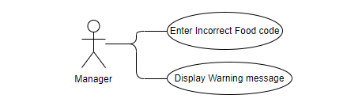

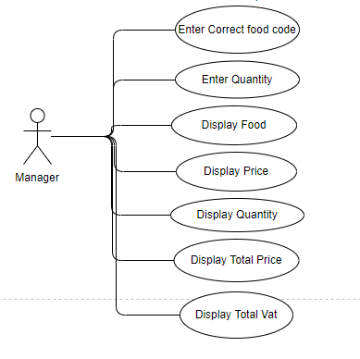

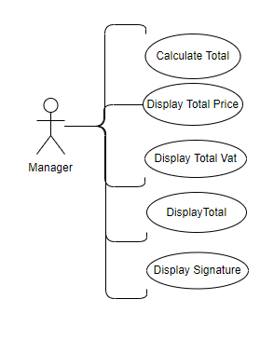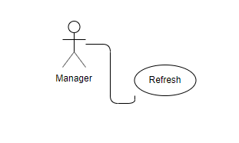

Use Case Description

|  |  |
| --- | --- |
| **USE CASE** | **Description** |
| Display Menu | The manager open the system and it display menu of the restaurant. |
| Enter Customer Name | The manager of the restaurant enter the customer name. |
| Enter Customer ID | The manager of the restaurant enter the customer ID. |
| Enter Food Code | The customer choice food code from menu.  The manager enter those food code |
| Select Quantity | The customer select quantity for all selected food.  The manager enter the quantity. |
| Display Food | The system display all selected food name. |
| Display Price | The system display all selected foods price individually. |
| Display Quantity | The system display all selected foods quantity individually. |
| Display Total Price | The system display all selected foods price individually which depend on quantity. |
| Display Total Vat | The system display all selected foods vat individually which depend on quantity. |
| Enter Incorrect Food Code | The manager enter incorrect food code. |
| Display Warning message | The system display warning message for incorrect food code. |
| Calculate Total | The system calculate total bill with vat for all selected food code. |
| Display Total | The system Display total bill with vat for all selected food code. |
| Refresh | The manager enter “M” to go main menu. |
|  |  |

**“Prototype Design”**

**Prototype:1**

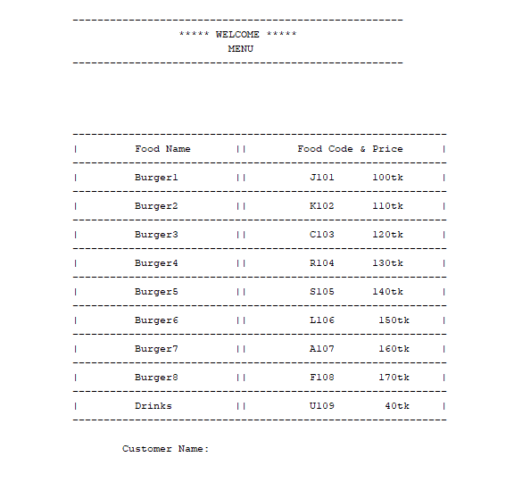

**Prototype:2**  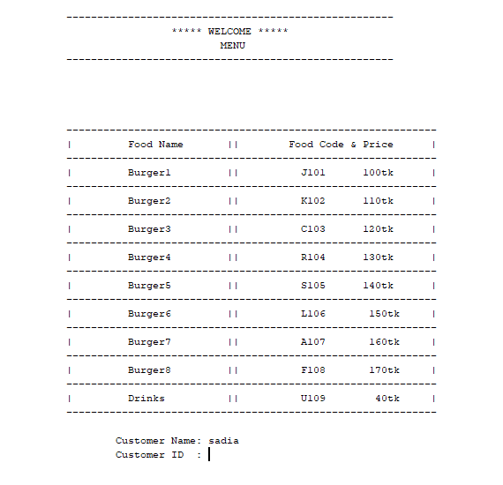

**Prototype:3**

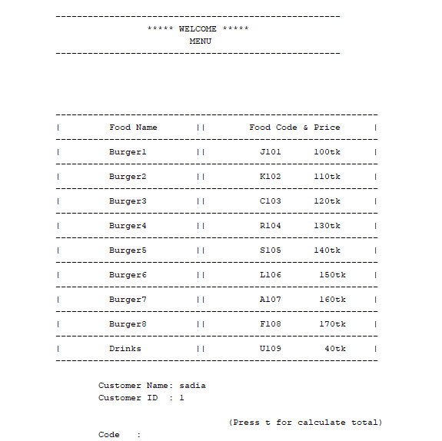

**Prototype:4**

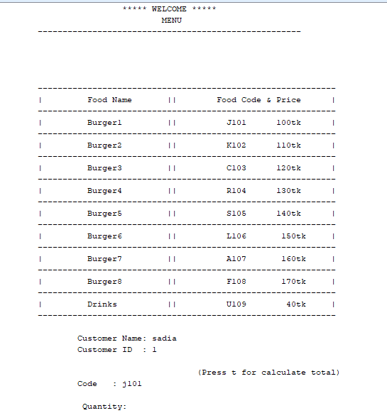

**Prototype:5**

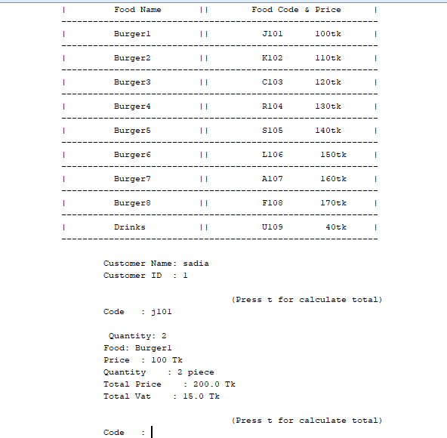

**Prototype:6**

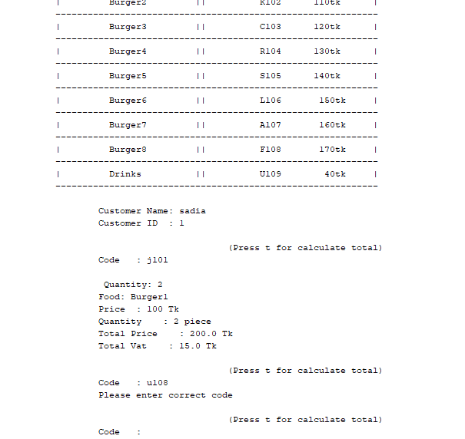

**Prototype:7**

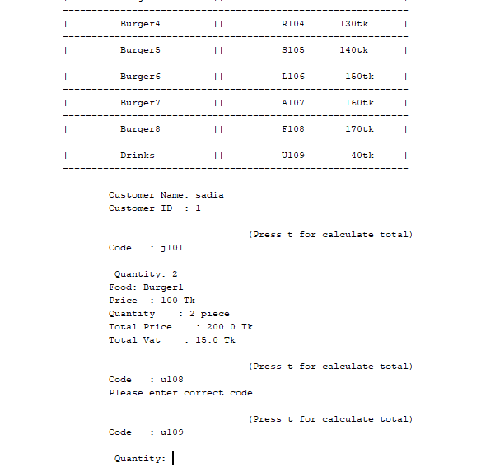

**Prototype:8**

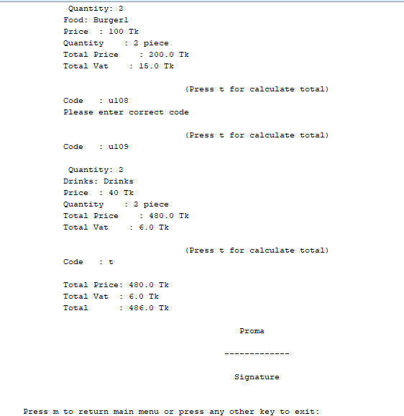

**Prototype:9**

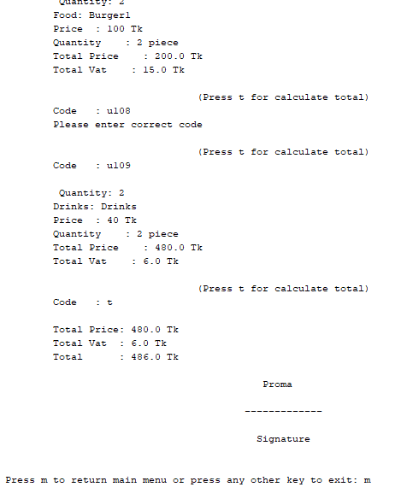

**Prototype:10**

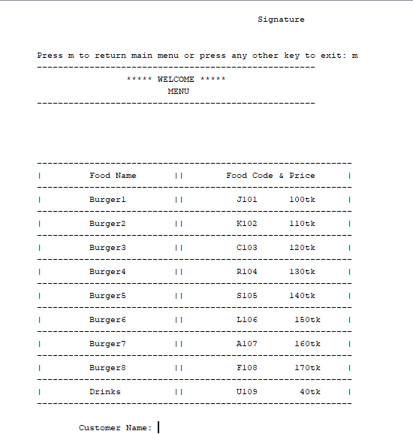

“Class Diagram”

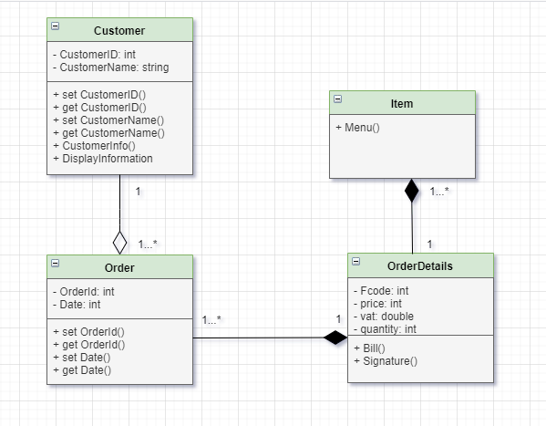

“Sequence Diagram”

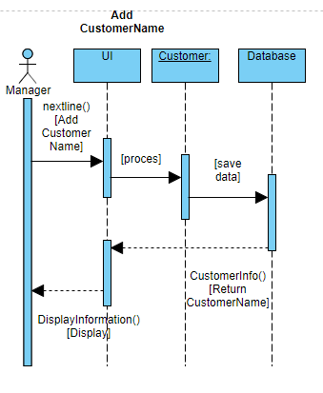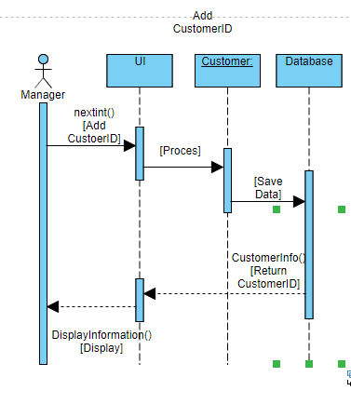

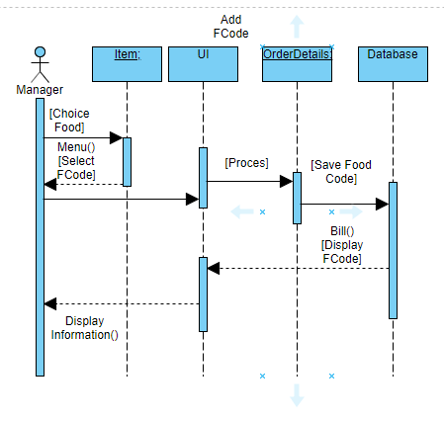

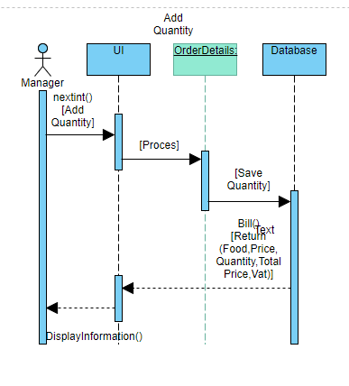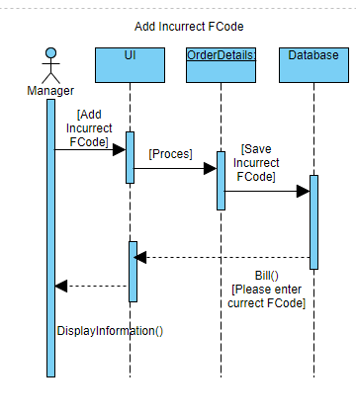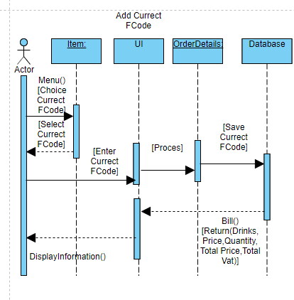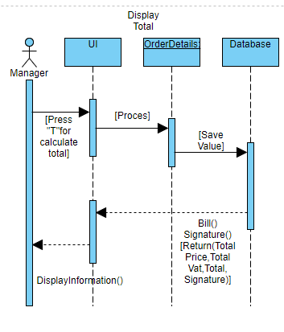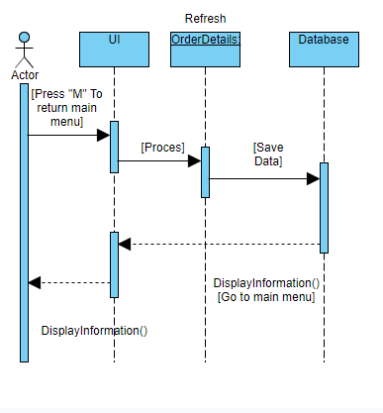

CUSTOMER .JAVA

package BURGER_RESTAURENT;

import java.util.Scanner;

import static BURGER_RESTAURENT.Item.Menu;

import static BURGER_RESTAURENT.OrderDetails.Bill;

import static BURGER_RESTAURENT.OrderDetails.Signature;

public class Customer {

private int CustomerId;

private String CustomerName;

public Customer(int CustomerId,String CustomerName,Order Order){

this.CustomerId=CustomerId;

this.CustomerName=CustomerName;

}

public int getCustomerId() {

return CustomerId;

}

public void setCustomerId(int CustomerId) {

this.CustomerId = CustomerId;

}

public String getCustomerName() {

return CustomerName;

}

public void setCustomerName(String CustomerName) {

this.CustomerName = CustomerName;

}

@Override

public String toString() {

return "Customer {" +

"CustomerId=" + CustomerId +

",CustomerName="+CustomerName +

'}';

}

public static void CustomerInfo(){

String CustomerName;

Scanner sc=new Scanner(System.in);

System.out.print(" \n \t\t\tCustomer Name: ");

CustomerName=sc.nextLine();

int CustomerId;

System.out.print(" \t\t\tCustomer ID : " );

Scanner scId=new Scanner(System.in);

CustomerId=scId.nextInt();

int i = 0;

Bill();

Signature();

}

public static void DisplayInformation()

{

System.out.println("\t\t-----------------------------------------------------");

System.out.println("\t\t ***** WELCOME ***** ");

System.out.println("\t\t MENU ");

System.out.println("\t\t-----------------------------------------------------\n\n\n\n");

Menu();

//2 char c;

//2Scanner sc=new Scanner(System.in);

//2c=sc.nextLine().charAt(0);

// to read a charter,we use next() function & next() function returns the next word in the input as a string//

//charAt(0) function returns 1st charter in that string//

//1OrderDetails obj=new OrderDetails();

//1obj.CustomerInfo();

//DisplayInformation();

//OrderDetails obj=new OrderDetails();

//obj.CustomerInfo();

CustomerInfo();

Scanner back=new Scanner(System.in);

System.out.print("\n\n\t\tPress m to return main menu or press any other key to exit: ");

int b;

b=back.nextLine().charAt(0);

if(b=='m') {

DisplayInformation();

}

}

}

CUSTOMER.JAVA

package BURGER_RESTAURENT;

public class Item {

public static void Menu(){

System.out.println("\t\t------------------------------------------------------------");

System.out.println("\t\t| Food Name || Food Code & Price |");

System.out.println("\t\t------------------------------------------------------------");

System.out.println("\t\t| Burger1 || J101 100tk |");

System.out.println("\t\t------------------------------------------------------------");

System.out.println("\t\t| Burger2 || K102 110tk |");

System.out.println("\t\t------------------------------------------------------------");

System.out.println("\t\t| Burger3 || C103 120tk |");

System.out.println("\t\t------------------------------------------------------------");

System.out.println("\t\t| Burger4 || R104 130tk |");

System.out.println("\t\t------------------------------------------------------------");

System.out.println("\t\t| Burger5 || S105 140tk |");

System.out.println("\t\t------------------------------------------------------------");

System.out.println("\t\t| Burger6 || L106 150tk |");

System.out.println("\t\t------------------------------------------------------------");

System.out.println("\t\t| Burger7 || A107 160tk |");

System.out.println("\t\t------------------------------------------------------------");

System.out.println("\t\t| Burger8 || F108 170tk |");

System.out.println("\t\t------------------------------------------------------------");

System.out.println("\t\t| Drinks || U109 40tk |");

System.out.println("\t\t------------------------------------------------------------");

}

}

ITEM.JAVA

package BURGER_RESTAURENT;

import java.lang.*;

public abstract class Order extends OrderDetails {

private int OrderId;

private int Date;

public Order(int OrderId, int Date){

this.OrderId = OrderId;

this.Date = Date;

}

public int getOrderId() {

return OrderId;

}

public void setOrderId(int OrderId) {

this.OrderId = OrderId;

}

public int getDate() {

return Date;

}

public void setDate(int Date) {

this.Date = Date;

}

public String toString() {

return "Order {" +

"OrderId=" + OrderId +

",Date =" + Date+

'}';

}

}

ORDER DETAILS.JAVA

package BURGER_RESTAURENT;

import java.util.Scanner;

public class OrderDetails{

static double t; //t= total price

public static void Bill()

{

String Fcode; //Fcode=food code

double tp=0,tv=0; //tp=total price & tv=total vat

int j; //insert code//

for(j=0;j<20;j++)

{

System.out.print("\n\t\t\t\t\t\t(Press t for calculate total)\n");

System.out.print("\t\t\tCode : ");

Scanner pc=new Scanner(System.in);

Fcode=pc.nextLine();

int price;

double vat;

int quantity = 0;

if("t".equals(Fcode)) //equals() use to compare object in java//

break;

switch(Fcode)

{

case "J101": case "j101":

price=100;

Scanner scQ=new Scanner(System.in); //

System.out.print(" \n \t\t\t Quantity: ");

quantity=scQ.nextInt();

tp=(tp+price)*quantity;

vat=Math.ceil(.15*price);

tv=+vat;

System.out.println("\t\t\tFood: Burger1");

System.out.println("\t\t\tPrice : "+price+" Tk");

System.out.println("\t\t\tQuantity : "+quantity+" piece");

System.out.println("\t\t\tTotal Price : "+tp+" Tk");

System.out.println("\t\t\tTotal Vat : "+tv+" Tk");

break;

case "K102": case"k102" :

price=110;

Scanner scQa=new Scanner(System.in); //

System.out.print(" \n \t\t\t Quantity: ");

quantity=scQa.nextInt();

tp=(tp+price)*quantity;

vat=Math.ceil(.15*price);

tv=+vat;

System.out.println("\t\t\tFood: Burger2");

System.out.println("\t\t\tPrice : "+price+" Tk");

System.out.println("\t\t\tQuantity : "+quantity+" piece");

System.out.println("\t\t\tTotal Price : "+tp+" Tk");

System.out.println("\t\t\tTotal Vat : "+tv+" Tk");

break;

case "C103": case "c103":

price=120;

Scanner scQb=new Scanner(System.in); //

System.out.print(" \n \t\t\t Quantity: ");

quantity=scQb.nextInt();

tp=(tp+price)*quantity;

vat=Math.ceil(.15*price);

tv=+vat;

System.out.println("\t\t\tFood: Burger3");

System.out.println("\t\t\tPrice : "+price+" Tk");

//System.out.println("\t\t\tVat : "+vat+" Tk");

System.out.println("\t\t\tQuantity : "+quantity+" piece");

System.out.println("\t\t\tTotal Price : "+tp+" Tk");

System.out.println("\t\t\tTotal Vat : "+tv+" Tk");

break;

case "R104": case "r104":

price=130;

Scanner scQc=new Scanner(System.in); //

System.out.print(" \n \t\t\t Quantity: ");

quantity=scQc.nextInt();

tp=(tp+price)*quantity;

vat=Math.ceil(.15*price);

tv=+vat;

System.out.println("\t\t\tFood: Burger4");

System.out.println("\t\t\tPrice : "+price+" Tk");

System.out.println("\t\t\tQuantity : "+quantity+" piece");

System.out.println("\t\t\tTotal Price : "+tp+" Tk");

System.out.println("\t\t\tTotal Vat : "+tv+" Tk");

break;

case "S105": case "s105":

price=140;

Scanner scQd=new Scanner(System.in); //

System.out.print(" \n \t\t\t Quantity: ");

quantity=scQd.nextInt();

tp=(tp+price)*quantity;

vat=Math.ceil(.15*price);

tv=+vat;

System.out.println("\t\t\tFood: Burger5");

System.out.println("\t\t\tPrice : "+price+" Tk");

System.out.println("\t\t\tQuantity : "+quantity+" piece");

System.out.println("\t\t\tTotal Price : "+tp+" Tk");

System.out.println("\t\t\tTotal Vat : "+tv+" Tk");

break;

case "L106": case "l106":

price=150;

Scanner scQe=new Scanner(System.in); //

System.out.print(" \n \t\t\t Quantity: ");

quantity=scQe.nextInt();

tp=(tp+price)*quantity;

vat=Math.ceil(.15*price);

tv=+vat;

System.out.println("\t\t\tFood : Burger6");

System.out.println("\t\t\tPrice : "+price+" Tk");

System.out.println("\t\t\tQuantity : "+quantity+" piece");

System.out.println("\t\t\tTotal Price : "+tp+" Tk");

System.out.println("\t\t\tTotal Vat : "+tv+" Tk");

break;

case "A107": case "a107":

price=160;

Scanner scQf=new Scanner(System.in); //

System.out.print(" \n \t\t\t Quantity: ");

quantity=scQf.nextInt();

tp=(tp+price)*quantity;

vat=Math.ceil(.15*price);

tv=+vat;

System.out.println("\t\t\tFood: Burger7");

System.out.println("\t\t\tPrice : "+price+" Tk");

System.out.println("\t\t\tQuantity : "+quantity+" piece");

System.out.println("\t\t\tTotal Price : "+tp+" Tk");

System.out.println("\t\t\tTotal Vat : "+tv+" Tk");

break;

case "F108": case "f108":

price=170;

Scanner scQg=new Scanner(System.in); //

System.out.print(" \n \t\t\t Quantity: ");

quantity=scQg.nextInt();

tp=(tp+price)*quantity;

vat=Math.ceil(.15*price);

tv=+vat;

System.out.println("\t\t\tFood: Burger8");

System.out.println("\t\t\tPrice : "+price+" Tk");

System.out.println("\t\t\tQuantity : "+quantity+" piece");

System.out.println("\t\t\tTotal Price : "+tp+" Tk");

System.out.println("\t\t\tTotal Vat : "+tv+" Tk");

break;

case "U109": case "u109":

price=40;

Scanner scQh=new Scanner(System.in); //

System.out.print(" \n \t\t\t Quantity: ");

quantity=scQh.nextInt();

tp=(tp+price)*quantity;

vat=Math.ceil(.15*price);

tv=+vat;

System.out.println("\t\t\tDrinks: Drinks");

System.out.println("\t\t\tPrice : "+price+" Tk");

System.out.println("\t\t\tQuantity : "+quantity+" piece");

System.out.println("\t\t\tTotal Price : "+tp+" Tk");

System.out.println("\t\t\tTotal Vat : "+tv+" Tk");

break;

default:

System.out.println("\t\t\tPlease enter correct code");

}

}

//end of for loop

System.out.println("\n\t\t\tTotal Price: "+tp+" Tk");

System.out.println("\t\t\tTotal Vat : "+tv+" Tk");

t=tp+tv;

System.out.println("\t\t\tTotal : "+t+" Tk");

}

public static void Signature()

{

System.out.println("\n\t\t\t\t\t\t\t Proma");

System.out.println("\n\t\t\t\t\t\t\t-------------");

System.out.println("\n\t\t\t\t\t\t\t Signature");

}

}

MAIN.JAVA

package BURGER_RESTAURENT;

import static BURGER_RESTAURENT.Customer.CustomerInfo;

import static BURGER_RESTAURENT.Customer.DisplayInformation;

import static BURGER_RESTAURENT.OrderDetails.Bill;

public class MainClass extends Item{

public static void main(String[] args)

{

DisplayInformation();

CustomerInfo();

// Bill();

//int x;

//Item obj1=new Item();

//Item obj=new Item("j101","Burger1", 100.00, 0.15);

// obj.Bill();

//obj.getItemId();

//System.out.println(obj.toString());

}

}